Student book answers

1.1 Scientists review the research of other scientists

Pages 2–3

Extend your understanding 1.1

1 According to Mendel, how many factors for a characteristic are present in the cells of each organism? Where do these factors come from?

There are two factors. One factor comes from each parent.

2 Why did Mendel have such an influence on genetics?

All of our current knowledge and understanding of genetics today are developed from Mendel’s work and his two principles of segregation and independent assortment. He was the first person to make accurate conclusions in regard to how genes work.

3 Search the Internet to research the work of either Linus Pauling or Erwin Chargaff and explain their contribution to Watson and Crick’s work.

Students’ answers will vary.

Watson and Crick’s work relied on the research of other scientists, including Linus Pauling and Erwin Chargaff.

Linus Pauling proposed a triple helix structure of DNA with the bases arranged on the outside. Watson and Crick disproved this model; however, Pauling’s research on the helix structure assisted them in their work and contributed to their accurate conclusions of the structure of DNA. If Pauling had the same access to Franklin’s X-ray crystallography images, he may have corrected his own model much sooner than Watson and Crick.

Erwin Chargaff identified that there were equal amounts of adenine and thymine in a double-stranded DNA molecule and equal amounts of cytosine and guanine. This assisted Watson and Crick with their base pairing of the larger bases always pairing with the smaller bases (adenine with thymine and cytosine with guanine).

4 Rosalind Franklin died from cancer at the age of 37. Watson and Crick received a Nobel Prize in 1962 for their work on the structure of DNA. The Nobel Prize cannot be awarded posthumously (after death). If Franklin had been alive, should she have been awarded the Nobel Prize with Watson and Crick? Provide arguments to support your answer.

Students’ answers will vary.

Yes, Franklin’s image was the missing piece of the puzzle. If she had been able to keep it to herself, she may have been able to publish the accurate structure of DNA and been awarded the Nobel Prize.

No, Watson and Crick used her image along with the other work of many other scientists. They used all this information together to work out the overall structure of DNA.

5 Wilkins showed Franklin’s results to Watson and Crick without her knowledge. If she had been given a choice, should she have shared her results with other scientists? Should all scientists share their results with each other? Provide reasons why or why not.

Students’ answers will vary.

No, Franklin should have used her results to form her own conclusions first and been able to publish it before other scientists had access to her images.

Yes, scientists collaborating and sharing results and knowledge lead to new scientific breakthroughs.

Student book answers

1.2 DNA consists of a sugar–phosphate backbone and four complementary nitrogen bases

Pages 4–5

Check your learning 1.2

Remember and understand

1 What is a nucleotide?

A nucleotide is an individual subunit of a nucleic acid, consisting of a 5 carbon sugar, a phosphate molecule and a nitrogen base.

2 Explain how nucleotides join together to form polynucleotides.

Nucleotides join together to form a polypeptide by the sugar of one nucleotide joining to the phosphate of the next nucleotide.

Apply and analyse

3 Explain how two polynucleotides can twist helically around each other to form a double helix of DNA.

One polynucleotide twists clockwise and the other twists anticlockwise to form a helix. A large nitrogen base (adenine and guanine) always pair with a small nitrogen base (thymine and cytosine) to give the correct spacing. The nitrogen bases between the two polynucleotides form hydrogen bonds joining the two polynucleotides together to form a double helix.

4 What part of the DNA molecule varies? What part remains constant?

The order of the nitrogen bases varies in the DNA molecule. The deoxyribose sugar and phosphate molecules that form the sugar–phosphate backbone remain constant.

5 How does the order of the bases on one polynucleotide chain determine the order of the bases on the other chain?

Nitrogen bases join by complementary base pairing on either strand; adenine always pairs with thymine, while cytosine always pairs with guanine. Where any particular is positioned on one polynucleotide, there will be a complementary base pair present at the exact location on the other polynucleotide to pair with it.

6 What is the complementary DNA sequence of GTTAGCCAGT?

CAATCGGTCA

Student book answers

1.3 Chromosomes are DNA molecules carrying genetic information in the form of genes

Pages 6–9

Check your learning 1.3

Remember and understand

1 How many chromosomes are in each of your cells?

46

2 What is karyotyping?

Karyotyping involves making a map of all the chromosomes arranged into their pairs according to size (largest to smallest) with the exception of the last pair, being the sex chromosomes.

3 What role does RNA play in the conversion of DNA information into protein?

RNA transcribes a gene, and takes the copy of gene from the nucleus to the cytoplasm where it is translated into a chain of amino acids to form a protein.

4 How is a protein like a string of beads?

A protein is a chain of amino acids held together by peptide bonds.

Apply and analyse

5 If part of a base sequence on one polynucleotide strand on DNA reads ACTGGCATTCAG, what is the base sequence of the corresponding part of the other polynucleotide strand? What is the base sequence of the RNA for which this strand acts as a template?

TGACCGTAAGTC

ACUGGCAUUCAG

6 What is the difference between transcription and translation?

Transcription is where a single-stranded RNA copy of the DNA template is made within the nucleus.

Translation is where the RNA sequence is converted into a chain of amino acids within the cytoplasm.

7 What would be the RNA sequence for the DNA sequence GTTAGCCAGT? (Remember to pair uracil with adenine.)

GAAUCGGUCA

Student book answers

1.4 Mitosis forms new somatic cells

Pages 10–11

Check your learning 1.4

Remember and understand

1 What is the difference between mitosis and cytokinesis?

Mitosis is the division of the genetic material to produce two identical nuclei. The cell then divides into two in the process of cytokinesis.

2 Why do cells undergo mitosis?

Organism growth and cell repair

3 In which phase do most cells spend most of their time?

Interphase

4 Describe what happens in each phase of mitosis.

Interphase – normal life of the cell; DNA replicates

Prophase – chromosomes appear, nuclear membrane dissolves, spindle fibres attach to centromere

Metaphase – chromosomes line up down the centre of the cell

Anaphase - spindles contract, separating the two chromatids at the centromere and pulling them to the end of the cell

Telophase - nuclear membrane reforms around the two sets of DNA

Cytokinesis - cell membrane divides into two

Apply and analyse

5 A cell that is about to undergo mitosis must double its amount of DNA. Suggest why this needs to occur.

A cell needs to double its amount of DNA in order for both daughter cells to receive identical sets of genetic material once cell division has occurred.

Evaluate and understand

6 Identify each of the stages of mitosis that are happening in Figure 1.18.

Answers will vary.

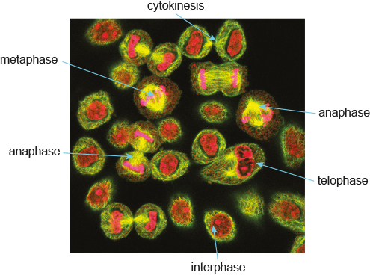

7 Write a story of a chromosome as it undergoes mitotic division. Describe how it replicates, remains attached at the centromere until anaphase, and the final goodbye during cytokinesis.

Students’ answers will vary. They should include the following points:

• The DNA coils tightly around histones and condenses to form visible chromosomes during late interphase.

• DNA replication occurs at the end of interphase.

• Replicated chromosomes form consisting of a two chromatids joined by a central centromere during prophase. Spindle fibres form attached to the centromere. The nuclear membrane dissolves.

• Chromosomes move to the centre of the cell where it lines up during metaphase. They are free to move as the nuclear membrane has dissolved.

• The chromatids are pulled apart from the centromere into single chromosomes during anaphase. Each chromosome is pulled to opposite sides of the cell in anaphase.

• Nuclear membranes form around each set of DNA during telophase.

• The cell membrane divides into two separate, genetically identical cells during cytokinesis.

Student book answers

1.5 Meiosis forms gamete cells

Pages 12–13

Check your learning 1.5

Remember and understand

1 What is the difference between a haploid cell and a diploid cell? Give an example of each.

A haploid cell contains half the genetic material of a diploid cell. An example of a haploid cell is a sperm cell, and an example of a diploid cell is a muscle cell.

2 Prepare a table showing the similarities and differences between mitosis and meiosis.

Tables will vary.

Similarities will include:

• the production of new cells

• both involve similar processes during each stage of cell division (for example, chromosomes line up during metaphase)

• DNA replication occurs prior to cell division

• cytokinesis separates new cells.

Differences will include:

• one cell division versus two cell divisions

• the formation of two identical cells versus four genetically different cells

• the formation of diploid, somatic cells versus haploid, gamete cells.

Apply and analyse

3 We all started from a single cell, a zygote, which then grew into an embryo. What type of cell division is involved in the growth of a zygote into an embryo? Explain your answer.

A zygote grows by mitosis into an embryo to create genetically identical cells. Meiosis is only used in the formation of gametes.

4 Are the offspring of sexually reproducing organisms identical to their parents?

No

5 Interphase is the ‘normal’ life stage of the cell – the stage between one mitotic division and the next. Interphase also occurs before meiotic divisions. What important process involving DNA occurs during interphase and why does it occur?

DNA replication occurs during interphase.

6 Why is it essential that the number of chromosomes is halved during meiosis?

The number of chromosomes needs to be halved to ensure when the haploid sperm and egg fuse during fertilisation the diploid zygote which forms contains the full set of chromosomes.

7 The chromosomes in Figure 1.23 are separating at the centromere. What phase of meiosis is the cell undergoing?

Anaphase

Student book answers

1.6 Alleles can produce dominant or recessive traits

Pages 14–15

Check your learning 1.6

Remember and understand

1 Dimples (D) is dominant to no dimples. Write the genotypes for individuals who:

a are homozygous for dimples DD

b are heterozygous for dimples Dd

c have no dimples. dd

2 What is a carrier?

An individual that carries the recessive allele but it is not expressed in the phenotype – a heterozygous individual.

Apply and analyse

3 If the children of a right-handed man and a left-handed woman are all left-handed, does this mean that left-handedness is dominant? Provide evidence to support your view.

No, the right-handed man could be a carrier (heterozygous) and pass on this recessive allele to his children. There would be a 50% chance of each child being left-handed if this was the case.

4 The trait for blue eyes is recessive to the trait for brown eyes. What are the chances of two blue-eyed parents having a brown-eyed child? What are the chances of two brown-eyed parents having a blue-eyed child?

There is no chance of two blue-eyed parents having a brown eyed child. bb × bb = 100% bb

Two brown-eyed parents depends on their genotype:

BB × BB = 100% BB, so no chance of blue-eyed children.

BB × Bb = 75%BB, 25% Bb, so no chance of blue-eyed children.

Bb × Bb = 25% BB, 50% Bb, 25%bb, so a 25% chance of having a blue-eyed child.

5 Wavy hair in humans is dominant to straight hair. A wavy-haired man and a straight-haired woman had two children. The first child had wavy hair and the second child had straight hair. State the genotype of all four individuals and use suitable symbols to show your working.

Students’ could show in a Punnett square: mother – hh, father – Hh, 1st child – Hh, 2nd child – hh.

Evaluate and create

6 A girl wants to check if her grey cat is heterozygous or homozygous for coat colour. Assuming breeding was ethical and time efficient, what cross should she carry out? What results would she obtain if the cat is:

a homozygous?

b heterozygous?

The girl should cross her cat with a recessive coloured cat. If any offspring are the recessive colour, her cat is heterozygous. If all offspring (after multiple breeding), she could assume her grey cat is homozygous dominant.

If her cat is heterozygous: Hh × hh = 50%Hh, 50%hh (50% chance of recessive coat being shown).

If her cat is homozygous dominant: HH × hh = 100% Hh (all will be grey).

As soon as she gets one that is the recessive colour, she knows her cat is heterozygous.

Student book answers

1.7 Alleles for blood group traits co-dominate

Pages 16–17

Check your learning 1.7

Remember and understand

1 Why is it important to know your blood group?

It is important to know your blood group for if you ever need a blood transfusion. Mixing different types of blood can cause clots to form that block blood vessels. A person who is transfused with the wrong type of blood can die.

2 From Table 1.1, in Australia what blood group is the:

a most common?

b least common?

The most common blood group is O and the least common is AB.

3 Complete the following table to record the possible genotypes that combine to produce each blood group phenotype and the sugars displayed.

|  |  |  |
| --- | --- | --- |
| BLOOD GROUP (PHENOTYPE) | POSSIBLE GENOTYPES | SUGARS DISPLAYED ON A RED BLOOD CELL |
| O | ii | No sugar |
| A | IAIA andIAi | A sugar |
| B | IBIB andIBi | B sugar |
| AB | IAIB | A and B sugars |

Apply and analyse

4 Consider two parents who are both blood group O. What blood groups could their children have?

They could only be blood group O as they can only receive a recessive allele from each parent.

5 Vinda is homozygous for blood group A. Julie is heterozygous for blood group B. Use a Punnett square to determine the possible genotype(s) and blood group(s) for a child of Vinda and Julie.

|  |  |  |
| --- | --- | --- |
|  | IA | IA |
| IB | IAIB | IAIB |
| i | IAi | IAi |

Vinda

Possible genotypes: ½ IAIB, ½ IAi

Possible phenotypes: ½ AB, ½ A

Julie

6 If Vinda and Julie have a second child, will the blood group of the first child affect that of the second? Explain your reasoning.

No, the punnet square shows the percentage chance of how many offspring in an ideal world will have this characteristic. Each gamete has a 50% chance of receiving a IB or i allele from Julie, regardless of what allele is present in any other gamete.

Student book answers

1.8 Alleles on the sex chromosomes produce sex-linked traits

Pages 18–21

Check your learning 1.8

Remember and understand

1 Why does a defect in a sex-linked gene affect males more than females?

As females have two X chromosomes, they will need two copies of alleles for an X-linked recessive trait for it to be expressed. X-linked traits are expressed more commonly in males as they have a single X chromosome.

Apply and analyse

2 A man and a woman, both of whom had normal sight, had three children, two boys and a girl. One of the boys had normal sight and the other was red–green colour blind. The girl had normal sight. Write the genotypes for this family.

Man: XY

Woman: XXe

Son (normal sight): XY

Son (red–green colour blind): XeY

Girl: XX or XXe

3 The girl from the family in question 2 married a normal-sighted man and had a son who was colour blind. Write the genotypes for this family.

Man: XY

Woman (girl from question 2): XXe

Son: XeY

4 The colour-blind son from the family in question 3 married a normal-sighted woman and had a son with normal sight and a colour-blind daughter. Write their genotypes.

Man: XeY (son from question 3)

Woman: XXe

Daughter: XeXe

Son: XY

5 What is the probability that the four girls in the family of the last Russian Tsar were carriers of the allele for haemophilia?

Alexandra was a carrier for the trait, so she had a 50% chance of passing an affected X chromosome on to each of her daughters.

6 Who will be affected by a Y-linked gene? Explain your answer.

Only males are affected by Y-linked genes because females do not have Y chromosomes.

7 If a man has mutated gene on his Y chromosome, which grandparent did he inherit it from?

The man inherited the mutated gene from his grandfather. Y chromosomes are only present in males, not females.

Evaluate and create

8 Tortoiseshell cats have fur coats that are a combination of orange and black. The gene for hair colour is found on the X chromosome.

a Explain why all tortoiseshell cats are female. Use diagrams to explain your answer.

Tortoiseshell is a sex-linked trait expressed in heterozygotes (cats that have both an orange allele and a black allele). To be heterozygous, you need two X chromosomes; therefore, males can either be black or orange but never tortoiseshell in colour.

b What colour would the offspring of a tortoiseshell and a black cat be?

Females will all be either black or tortoiseshell, and males will be either orange or black.

Student book answers

1.9 Inheritance of traits can be shown on pedigrees

Pages 22–25

Check your learning 1.9

Apply and analyse

1 Some people have ear lobes that hang free and some people’s are attached. Natalie has attached ear lobes but both Natalie’s parents and her brother, Daniel, have free-hanging ear lobes as shown in the pedigree (Figure 1.41).

a Is the characteristic of free-hanging ear lobes a dominant trait or a recessive trait? Explain your choice.

Free-hanging ear lobes is a dominant trait. If free-hanging was recessive, then all the children would also have the recessive trait; however, Natalie has attached ear lobes.

b Use suitable symbols to represent the alleles for the ear lobe gene, then write the genotypes of:

i Natalie ff

ii Natalie’s parents. Mum: Ff, Dad: Ff

c What are the possible genotypes for Daniel?

Daniel could be either Ff or FF.

2 A particular X-linked disease causes weakening of the muscles and loss of coordination. This often leads to death in childhood. A pedigree for this disease is shown in Figure 1.42.

a Use this pedigree and suitable symbols to show the genotype of individuals I1, I2 and II5. What must be the genotype of individual 4?

Weakening muscles: Xm

1 XY

2 XXm

3 XY

4 XXm

b What is a carrier? Identify one carrier in the pedigree shown in Figure 1.42.

A carrier is a heterozygous individual whho has the allele for the trait but does not show the phenotype (the trait is not expressed). Individuals 2 and 4 are carriers.

3 Look at Figure 1.43.

a In this family pedigree, is the characteristic indicated by shading dominant or recessive? Explain.

The characteristic is autosomal recessive as equal numbers of males and females are affected, and an affected child had unaffected parents.

b If R represents the allele for the dominant trait and r represents the allele for the recessive trait, write the genotypes for I1, I2 and person A.

Genotypes: I1 (Rr), I2 (Rr), A (Rr)

c If A and her partner had another child, what is the chance of the child having the characteristic indicated by shading? Show your working.

Chances of a child showing the trait (rr): 50%

|  |  |  |
| --- | --- | --- |
|  | r | r |
| R | Rr | Rr |
| r | rr | rr |

4 The pedigrees in Figure 1.44 show the inheritance of two genetic disorders (vision and limb defects) in the same family.

a Is the allele responsible for the vision defect dominant or recessive? Explain your choice.

The gene for vision defect is dominant – two affected parents have an unaffected child.

b Is the allele responsible for the limb defect dominant or recessive? Explain your choice.

Gene for limb defect is recessive – an affected child has unaffected parents.

Student book answers

1.10 Mutations are changes in the DNA sequence

Pages 26–29

Check your learning 1.10

Remember and understand

1 Define ‘mutation’.

A mutation is a heritable change in the structure or amount of the genetic material.

2 What is a mutagen? Give some examples of mutagens and how they act to cause mutations.

A mutagen is an environmental factor that can increase the frequency of mutation. These can be radiation, chemical (cigarette smoke) or ultraviolet light.

3 What is a trisomy? Give an example of a trisomy in humans.

Trisomy is the presence of an extra chromosome in the karyotype. Down syndrome has three copies of chromosome 21. Edwards’ syndrome has three copies of chromosome 18.

4 What is a frameshift mutation?

A frameshift mutation involves a base deletion or insertion. This moves the reading frame and therefore alters more than one amino acid within a protein as the entire reading frame has shifted.

Evaluate and create

5 Can mutations ever be advantageous? Provide evidence to support your answer.

Yes, sometimes mutations can be beneficial and can form new alleles. Examples in humans include blue eyes and red hair. Mutations in bacteria can help the microbe become resistant to new antibiotics, and in viruses enable them to more easily infect their hosts. The stem cells that produce white blood cells regularly rearrange the small section of DNA that forms antibodies, which help us fight disease. Although the latter is not strictly a mutation, the principle is the same.

6 Draw a series of pictures that show non-disjunction occurring in meiosis.

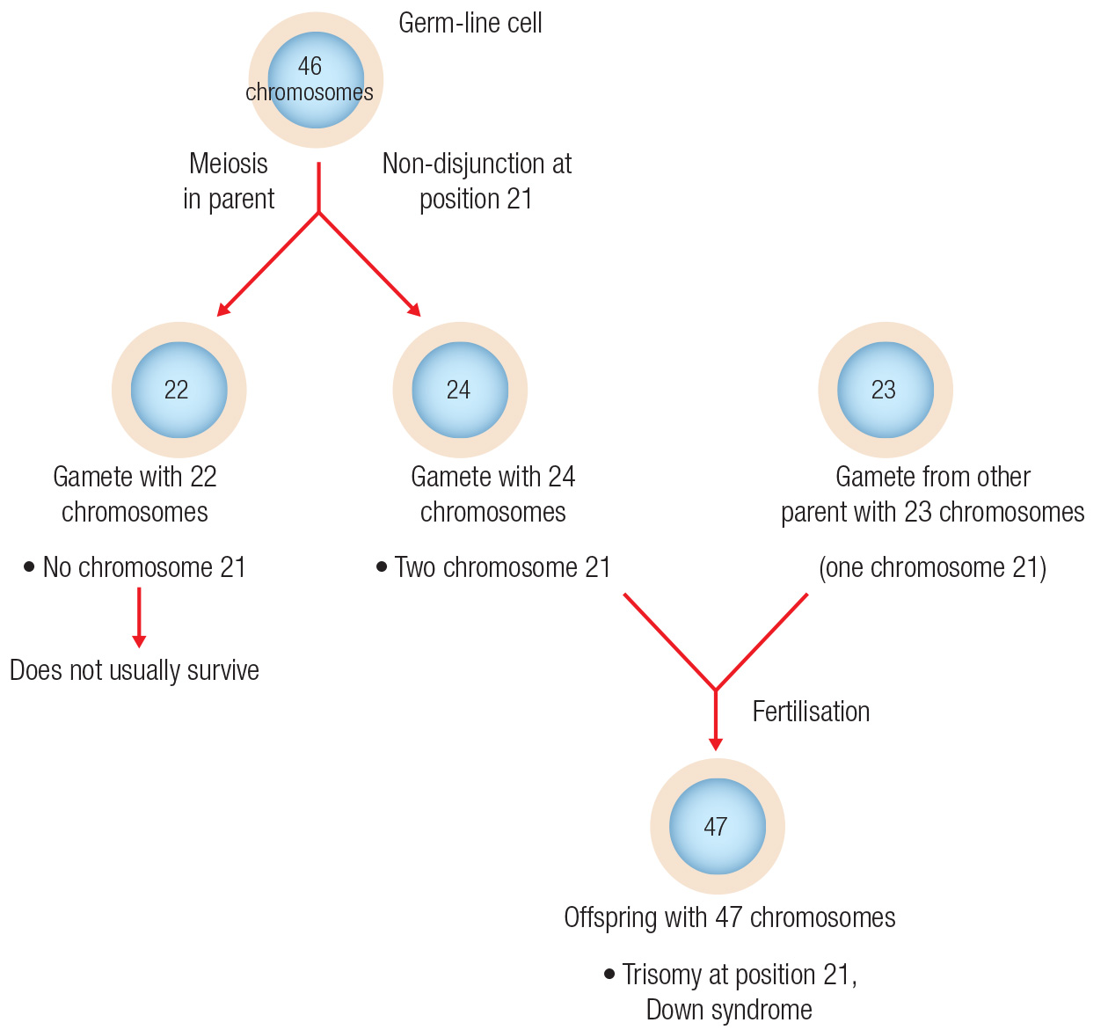

7 How would you test if a male had Klinefelter's syndrome?

Karyotype to determine if they have an extra X chromosome

Student book answers

1.11 Genes can be tested

Pages 30–31

Extend your understanding 1.11

1 Research one of the diseases mentioned in the text. What are the symptoms of the disorder? How can the disorder be treated? What is the life expectancy of a person suffering from the disorder?

Student answers will vary.

2 List two advantages and disadvantages of pre-natal testing.

Advantages:

• Early testing can alleviate any concerns the parents may have.

• Early detection allows early treatment to minimise the progression of any diseases.

Disadvantages:

• Detection of a possible problems can cause the mother to become stressed which can affect the unborn fetus.

• Some parents cannot afford the cost of the tests.

3 Prepare a debate on the topic ‘Public funding for pre-natal testing should only be made available to high-risk pregnant women’.

Student answers will vary.

Student book answers

1.12 Genes can be manipulated

Pages 32–33

Extend your understanding 1.12

1 Give an example of an organism that has been genetically engineered for use in agriculture. How has it been useful?

Students’ answers will vary.

For example, papaya has been genetically resistant, so it is resistant to the ring spot virus. These GM papaya can now survive this disease while non-transgenic papaya cannot.

2 Briefly describe a method that is used to insert ‘new’ genes into plant cells.

The desired gene is taken and inserted into a plasmid. The plasmid is placed into a self-replicating bacterium. The bacteria are used to infect the plant embryo cells to create the GM plant.

3 What are some reasons for genetically engineering plants?

Students’ answers will vary.

Reasons include providing crops with increased growth and yield; and pest resistance, insect resistance, drought resistance, pesticide and herbicide resistance.

4 As a consumer, do you think that food containing GMOs should be labelled?

Students’ answers will vary.

Yes, they should identify if they have foreign DNA in them as some individuals do not wish to consume them.

5 What factors would influence your decision to purchase or not to purchase food containing GMOs?

Students’ answers will vary.

Examples of factors include price, if they affect your health, and whether they been sprayed with herbicides or pesticides.

Student book answers

1.13 Genetic engineering is used in medicine

Pages 34–35

Extend your understanding 1.13

1 What is the aim of gene cloning?

The aim of gene cloning is to produce large numbers of a desired gene using a microorganism.

2 Describe the process used to produce human insulin by gene cloning.

The insulin gene is isolated and placed into a plasmid to create a recombinant plasmid. This is then placed inside a self-replicating bacterial cell. The bacterial cell produces the human insulin protein from the human insulin gene that has been inserted.

3 Why do scientists choose bacteria to clone human genes?

Bacteria are self-replicating and divide rapidly. They can produce the human protein in vast quantities, which can be purified and used to treat a human disease.

4 Give an example of a successful gene therapy treatment for a disease.

Students’ answers may vary. An example is cystic fibrosis.

5 Why is the use of induced pluripotent cells more acceptable to some people than embryonic stem cells?

Embryonic stem cells are often viewed by people as potential life, whereas induced pluripotent cells have come from cells other than embryos.

Student book answers

Review 1

Pages 36–37

Remember and understand

1 Name the four nucleotides found in DNA.

Adenine, thymine, cytosine, guanine

2 Use the terms ‘gametes’ and ‘fertilisation’ to explain how DNA is transferred from one generation to the next.

Half the DNA of a parent cell is contained in the gamete cell. The gamete cells (and egg from one parent and the sperm from the other parent) meet during fertilisation, and the DNA from both parents combine to form the offspring.

3 Relate a chromosome to a molecule of DNA and explain how the replication of DNA is important for both mitosis and meiosis.

A chromosome is a molecule of DNA. DNA must be replicated before cell mitosis to ensure there is a complete set of diploid chromosomes for each cell. Meiosis creates four daughter cells with a haploid set of chromosomes. This, therefore, needs four sets of chromosomes or two sets of diploid chromosomes. The DNA must be duplicated before meiosis can occur.

4 Describe three differences between the structure or function of DNA and RNA.

|  |  |
| --- | --- |
| DNA | RNA |
| Deoxygenated five-carbon sugar | Oxygenated five-carbon sugar |
| Has two complementary strands | Single-stranded |
| Contains the nitrogen base thymine | Contains the nitrogen base uracil |

5 Use words and/or diagrams to explain the differences between:

a nucleotide base and codon

Triplet is used to describe three nitrogen bases on DNA. Codon is used to describe three nitrogen bases on mRNA.

b diploid and haploid

Diploid is two copies of each chromosomes in a cell. Haploid is a single copy of each chromosome in a cell.

6 What is a monohybrid cross?

A monohybrid cross is a breeding experiment between two individuals that differ in a single trait.

7 What were Mendel’s conclusions from his work on breeding peas?

Mendel’s conclusions were that two factors (genes) control each characteristic. Each factor separates from the other factor before fertilisation and then recombines (there is no blending).

8 What is the difference between the following pairs of terms? a Autosome and sex chromosome b Gene and allele c Heterozygous and homozygous

a Autosome and sex chromosome

Autosomes are the non-sex chromosomes (22 in humans). Sex chromosomes are the X and/or Y chromosomes that determine the sex of the organism.

b Gene and allele

A gene is a piece of a chromosome that codes for a particular characteristic. An allele is a type of gene.

c Heterozygous and homozygous

Heterozygous is an individual that has two different types of alleles. Homozygous is an individual that has two alleles that are the same.

9 Explain what is meant by the following formula:

Phenotype = genotype + environment

The expression of a trait (phenotype) is dependent on the organism’s genotype and its environment. For example, Siamese cats grow white hair at body temperature, but the enzyme that produces the white colour breaks down at cooler temperatures. This means that the extremities of the cat’s body (such as ears, feet and face) are darker in colour.

10 Define:

a GMO

A GMO (or genetically modified organism) is an organism that has had its genetic material modified in some way.

b transgenic organism.

A transgenic organism is created when the DNA from one organism is combined with the genetic material from another organism.

11 Explain the process of:

a gene cloning

Genes from an organism can be placed into a microorganism and grown up into large numbers. A desired gene is isolated using restriction enzymes and placed into a plasmid using DNA ligase. The plasmid is placed in a bacterial cell, which produces large quantities of the protein from the inserted gene.

b gene therapy.

Gene therapy involves replacing a faulty gene with a healthy gene. This is done with the help of restriction enzymes to cut the DNA, DNA ligase to stick the DNA back together, and a vector (often a virus) to insert the DNA into the cell.

Apply and analyse

12 If a gene contains 600 nitrogenous bases, how many amino acids would be incorporated into the resulting protein?

600 ÷ 3 = 200 codons. However, the STOP codon does not code for an amino acid, so there will be 199 amino acids in the protein.

13 Which of the following is not a function of mitosis?

A Replenishing the epithelial cells of the small intestine that are shed daily

B Forming new red blood cells to replace those that are worn out

C Forming cells for sexual reproduction

D Repairing cuts and abrasions of the skin

Answer C is not part of mitosis – it is meiosis.

14 What sort of information can be determined from the pedigree shown in Figure 1.60? List as many points as possible.

This is an autosomal recessive trait. Individual I1 is a male (heterozygous) carrier; I2 is a female who is homozygous for the trait; II1 is a female who is homozygous for the trait; II2 and II3 are male carriers; II4 is a female who is homozygous for the trait; III1 is a male carrier; and III2 is a male who is homozygous for the trait.

15 Can large-scale genetic screening programs reduce the prevalence of genetic diseases? Explain your answer.

Large-scale genetic testing programs may reduce the occurrence of diseases such as cystic fibrosis as people who are carriers of the disease may consider using genetic testing on their embryo to ensure a healthy baby. Most commonly, genetic testing is done on adults to allow for early intervention for diseases. This will not change the prevalence of the disease.

16 Gene therapy has been proposed as a treatment for a young boy suffering from Duchenne’s muscular dystrophy, a degenerative disorder of the muscles. Describe three factors that should be considered by the boy’s health team prior to treatment.

The three factors that should be considered are:

• the effectiveness of the treatment in improving the boy’s lifestyle

• the genetic cause of the disease (can the gene be replaced?)

• how the gene will be transferred into the boy.

Evaluate and create

17 Does a chromosome or a gene provide the most information about the make-up of an individual? Explain the reasons why.

A chromosome has many genes incorporated into its DNA. Therefore, it will provide more information about an individual than a single gene.

18 A newborn baby shows distinct facial abnormalities. A karyotype (Figure 1.61) was prepared to determine whether there were any chromosomal abnormalities.

a What is the total number of chromosomes shown?

Total number of chromosomes: 47

b Is the child male or female? How do you know?

The child is male (XY).

c As the geneticist, what would you advise the parents about the health of their baby?

The child has an extra chromosome 21. This means the child has Down syndrome.

19 If both parents have achondroplasia, what are the chances of their children being unaffected?

If both parents are heterozygous for achondroplasia (most likely as individuals who are homozygous for the trait do not survive), then 25% of their children will be unaffected.

20 Phenylketonuria is an autosomal recessive genetic disorder. It results in the lack of production of an enzyme that is needed to metabolise the amino acid phenylalanine to the amino acid tyrosine. A diet low in phenylalanine and high in tyrosine is prescribed to people with phenylketonuria to avoid progressive mental retardation. Every child born in Australia is now screened for phenylketonuria within weeks of birth. What is the benefit of such genetic screening?

Genetic screening for phenylketonuria at birth means that early intervention by changing the child’s diet can prevent or restrict the progressive mental retardation.

21 Create a teaching resource that could be used to teach a Year 7 student about the process of cell division.

Students’ answers will vary.

22 Select a genetic disease and create a pamphlet for display in the reception area of a doctor’s surgery. The pamphlet should outline information about the cause of the disease (gene or chromosomal abnormality), pattern(s) of inheritance, the frequency of the disease in the population, diagnosis, symptoms and treatment.

Students’ answers will vary.

23 Produce a brochure that promotes the benefits of purchasing organic and non-GM foods. Alternatively, produce a brochure promoting the benefits of GM foods.

Students’ answers will vary.

Ethical understanding

24 The debate around embryonic stem cells is heated. What are the reasons for and against using embryonic stem cells? How have governments intervened in this area? Based on your findings, do you think that using embryonic stem cells could provide benefits to humans?

Students’ answers will vary.

Research

25 Choose one of the following topics for a research project. Some questions have been included to help you begin your research. Present your report in a format of your own choosing.

Breast cancer

To what extent does a family history affect an individual’s chances of developing breast cancer? How is breast cancer detected and treated?

A shrinking Y chromosome

The Y chromosome has been losing genes over the course of time so that it is now only a fraction of the size of the X chromosome. How has this happened? Will it disappear altogether? What is the future of the Y chromosome? What effect will this have on humans?

Stem cell survival technique

Australian scientists have found a way to keep muscle stem cells alive so they can regenerate damaged tissue around them. Why is this technique a breakthrough? What does the technique involve? What are the immediate uses of this technique?

Students’ answers will vary.